**Unsupervised Machine Learning**

In the previous topic, we learned supervised machine learning in which models are trained using labeled data under the supervision of training data. But there may be many cases in which we do not have labeled data and need to find the hidden patterns from the given dataset. So, to solve such types of cases in machine learning, we need unsupervised learning techniques.

Unsupervised learning cannot be directly applied to a regression or classification problem because unlike supervised learning, we have the input data but no corresponding output data. The goal of unsupervised learning is to **find the underlying structure of dataset, group that data according to similarities, and represent that dataset in a compressed format**.

**Example:** Suppose the unsupervised learning algorithm is given an input dataset containing images of different types of cats and dogs. The algorithm is never trained upon the given dataset, which means it does not have any idea about the features of the dataset. The task of the unsupervised learning algorithm is to identify the image features on their own. Unsupervised learning algorithm will perform this task by clustering the image dataset into the groups according to similarities between images.

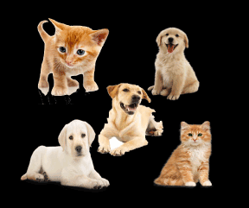

Working of unsupervised learning can be understood by the below diagram:

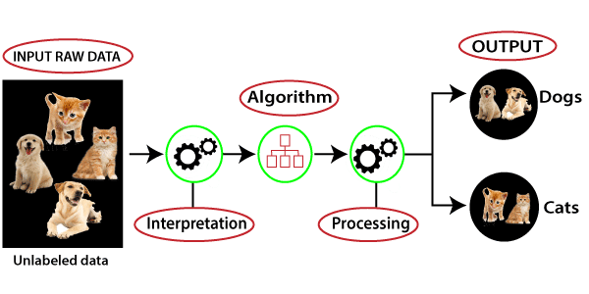

Here, we have taken an unlabeled input data, which means it is not categorized and corresponding outputs are also not given. Now, this unlabeled input data is fed to the machine learning model in order to train it. Firstly, it will interpret the raw data to find the hidden patterns from the data and then will apply suitable algorithms such as k-means clustering, Decision tree, etc.

Once it applies the suitable algorithm, the algorithm divides the data objects into groups according to the similarities and difference between the objects.

## Types of Unsupervised Learning Algorithm:

The unsupervised learning algorithm can be further categorized into two types of problems:

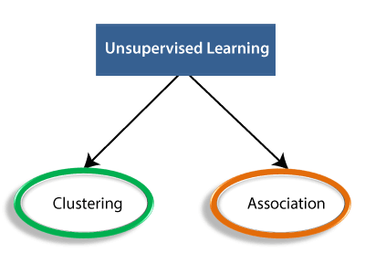

* **Clustering**: Clustering is a method of grouping the objects into clusters such that objects with most similarities remains into a group and has less or no similarities with the objects of another group. Cluster analysis finds the commonalities between the data objects and categorizes them as per the presence and absence of those commonalities.
* **Association**: An association rule is an unsupervised learning method which is used for finding the relationships between variables in the large database. It determines the set of items that occurs together in the dataset. Association rule makes marketing strategy more effective. Such as people who buy X item (suppose a bread) are also tend to purchase Y (Butter/Jam) item. A typical example of Association rule is Market Basket Analysis.

#### Note: We will learn these algorithms in later chapters.

## Unsupervised Learning algorithms:

Below is the list of some popular unsupervised learning algorithms:

* **K-means clustering**
* **KNN (k-nearest neighbors)**
* **Hierarchal clustering**
* **Anomaly detection**
* **Neural Networks**
* **Principle Component Analysis**
* **Independent Component Analysis**
* **Apriori algorithm**
* **Singular value decomposition**